Set Custom Start Menu – Windows 8.1

Info take from here: <http://www.scconfigmgr.com/2013/10/23/modify-the-windows-8-1-start-screen-during-osd-in-configmgr-2012/>

**EXPORT Customized Start Screen:**

Using PowerShell

1. On the virtual machine that you have modified the Start screen layout on, open an elevated PowerShell console.

2. Run the following command (Make sure you have a c:\Temp Folder or change the path if necessary):

Export-StartLayout -As Bin -Path C:\Temp\appsFolderLayout.bin

3. You should now have a file called appsFolderLayout.bin in C:\Temp.

4. Copy the appsFolderLayout.bin to your Content Library folder (CM Source Share).

**Deploy**

­

1. On your Primary Site server, open the ConfigMgr console and create a new Package.

2. Call the new package something like Start Screen Layout – Windows 8.1 Enterprise x64.

3. Enter the path to the folder where the appsFolderLayout.bin file is stored in the Source folder field.

4. Do not create a program for the package.

5. Finish the wizard and then distribute the package to your Distributions Points.

Modify your OSD task sequence

1. Edit your task sequence used for deploying Windows 8.1.

2. Add a Run Command Line step somewhere after the Setup Windows and Configuration step.

3. Call it something like Start Screen Layout modification.

4. As the Command line, enter the following:

xcopy appsFolderLayout.bin "%SystemDrive%\Users\Default\AppData\Local\Microsoft\Windows" /Q /Y

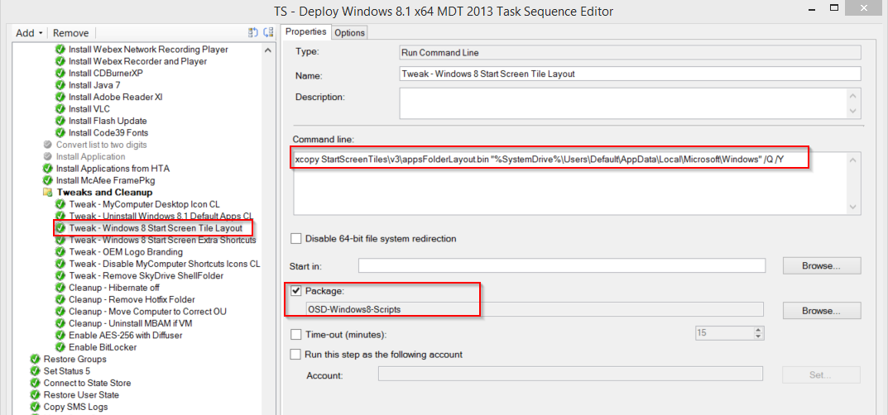

5. Put a check mark in the Package box and browse for the package that you created earlier containing the appsFolderLayout.bin file.

6. Apply the changes in your task sequence.

7. Start a new deployment of a system and let it complete.

8. Log on with a user account in your domain. The Start screen should now look like your modifications from the virtual machine used earlier.

Currently customized to look like:

